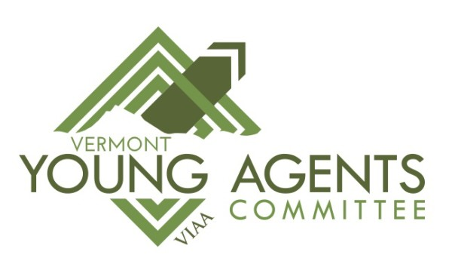
Vermont Young Agents
Membership Commitment

Name: ___________________________________________________
Agency/Company: __________________________________________
Address: __________________________________________________
City, State, Zip: _____________________________________________
Phone #: __________________________________________________
Cell #: ____________________________________________________
Date of Birth: _______________
# Years in the Industry: ________
E-mail address: _____________________________________________

REQUIREMENTS: To be a member of the Vermont Young Agents Committee you must be under the age of forty (40) or have less than 10 years experience in the insurance industry. Committee members must be a regular agency member, company partner or associate member of the VIAA and be in good standing. There is also a requirement that you must regularly attend Young Agent Committee sponsored events throughout the calendar year and have no more than 1 unexcused absence from the scheduled meetings.

I hereby agree to observe the By-laws and Policies of the Vermont Young Agents Committee. I certify that I meet all the membership requirements of the Committee and that information contained in this commitment form are true and correct.

Signature: ___________________________________________________

Date: _______________________________________________________

