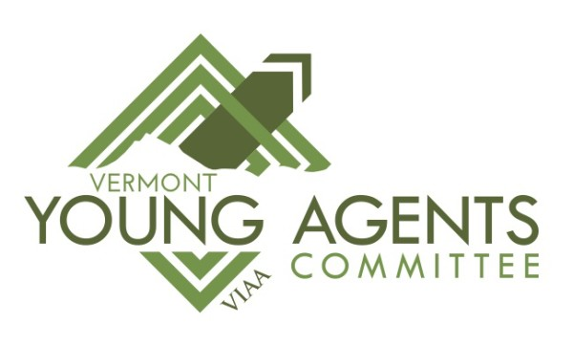
Vermont Young Agents
MEMBER AT LARGE

Would you like to be a MEMBER of the Vermont Young Agents?
- Networking opportunities statewide with other experienced professionals
- Continuing education opportunities
- Gaining knowledge in the insurance industry
- Email distribution list with information, articles and other resources available to young agents
- Participation in Charitable events
- No membership fee
ELIGIBILITY
Vermont Young Agents Committee is open to all young agents who are either:
- Under the age of 40, or
- In the industry less than 10 years
- Regular agency member, company partner or associate member of VIAA in good standing

______ I would like to be a member at large
______ I am also interested in joining the Young Agent Committee as openings arise

Name: ___________________________________________________
Agency/Company: __________________________________________
Address: __________________________________________________
Job Title: _____________________________________________
Phone #: __________________________________________________
Cell #: ____________________________________________________
Date of Birth: _______________
# Years in the Industry: ________
E-mail address: _____________________________________________

